**USECASE SPECIFICATIONS FOR AIMS SYSTEM**

## **USECASE “PLACE ORDER”**

### ***Descriptions and flows***

|  |  |  |  |  |  |  |
| --- | --- | --- | --- | --- | --- | --- |
| **Usecase** | **PLACE ORDER** | | | | | |
| **Usecase code** | **UC-250** | | | | | |
| **Actors** | Customer | | | | | |
| **Brief description** | After having selected the goods to buy to the cart, customer requests to place an order with delivery details. Order payment must be done before the items being delivered. | | | | | |
| **Preconditions** | - The cart of user has had some items  - Customer is viewing the cart | | | | | |
| **Main flow of event** | **Step** | **Actor** | **Action** | | | |
| 1 | Customer | Customer chooses to place an order | | | |
| 2 | System | AIMS checks and availability of products in the cart | | | |
| 3 | System | AIMS shows the form to fill delivery information and delivery instruction | | | |
| 4 | Customer | Customer fills in the delivery information and delivery instruction and submit | | | |
| 5 | System | AIMS validates the customer's input | | | |
| 6 | System | AIMS calculates fees | | | |
| 7 | System | AIMS displays the invoice with details and total amount of money to pay | | | |
| 8 | Customer | Customer confirms the invoice | | | |
| 9 | System | AIMS saves the invoice | | | |
| 10 | System | AIMS calls "PAY ORDER" usecase | | | |
| 11 | System | AIMS notifies customer about order successful placement and clears the cart | | | |
| **Alternative flow of event** | **No.** | **At step** | **Conditions** | **Actor** | **Action** | **Cont. at step** |
| 1 | 1-10 |  | Customer | Customer cancels order |  |
| System | AIMS saves current state of the cart and clears all delivery and transaction information |
| 2 | After 10 |  | Customer | Customer cancels order |  |
| System | AIMS asks for cancel order confirmation |
| Customer | Customer confirms cancellation |
| System | AIMS calls “REFUND” usecase |
| 3 | 2 | There is a product of which quantity is less than the ordered quantity | System | AIMS asks the customer to update the cart | 2 |
| Customer | Customer updates the cart |
| 4 | 5 | Customer chooses to place rush order in previous step | System | AIMS calls “PLACE RUSH ORDER” usecase | 6 |
| 5 | 5 | Customer lefts blank mandatory fields | System | AIMS asks customer to fill in the mandatory fields | 3 |
| 6 | 5 | Phone number is invalid | System | AIMS asks customer to enter a valid phone number | 3 |
| 7 | 8 | Customer declines invoice | System |  | 1 |
| 8 | 11 | Payment failed | System | AIMS notifies about failure & keeps the cart’s current state | 1 |
| **Postconditions** | - The order has a state (success/failed) | | | | | |

**Activity diagram**

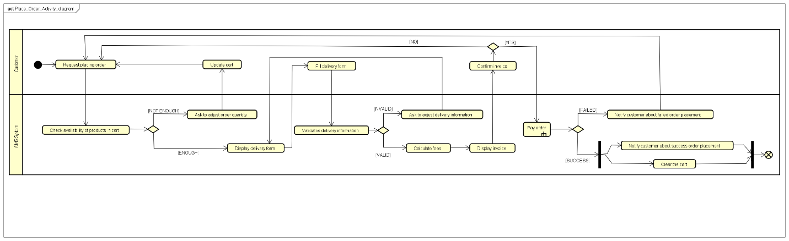

### ***Input data***

**Input data for ordering quantity**

|  |  |  |  |  |  |
| --- | --- | --- | --- | --- | --- |
| **No.** | **Data field** | **Description** | **Mandatory** | **Valid conditions** | **Example** |
| 1 | Quantity | Positive integer | Yes | Less than currently available number of selected product | 6 |

**Input data for delivery information**

|  |  |  |  |  |  |
| --- | --- | --- | --- | --- | --- |
| **No.** | **Data field** | **Description** | **Mandatory** | **Valid conditions** | **Example** |
| 1 | Receiver name |  | Yes |  | Nguyen Thi Thu Trang |
| 2 | Phone number |  | Yes | - All numbers  - At least 10 digits | 0123456789 |
| 3 | Province | Select from list | Yes |  | Hanoi |
| 4 | District | Select from list | Yes |  | Dong Da |
| 5 | Ward | Select from list | Yes |  | Trung Phung |
| 6 | Address |  | Yes |  | 123 X Street |
| 7 | Shipping notes/instruction |  | No |  | Turn left on the last crossroad. Please ship in work time |

### ***Output data***

**Output data for displaying cart**

|  |  |  |  |  |
| --- | --- | --- | --- | --- |
| **No.** | **Data field** | **Description** | **Format** | **Example** |
| 1 | Title | Title of media product | String | Gone with the wind |
| 2 | Quantity | Order quantity of corresponding media product | - Space separating thousands  - Positive integer | 5 |
| 3 | Price | Price of corresponding media product | 120 000 |
| 4 | Amount | Total money for corresponding media product | 600 000 |
| 5 | Subtotal before VAT | Total price of products in the cart without VAT | 600 000 |
| 6 | Subtotal | Total price of products in the cart with VAT | 606 000 |
| 7 | Currency | Type of currency used for payment | VND |

**Output data for displaying invoice**

|  |  |  |  |  |
| --- | --- | --- | --- | --- |
| **No.** | **Data field** | **Description** | **Format** | **Example** |
| 1 | Title | Title of media product | String | Gone with the wind |
| 2 | Quantity | Order quantity of corresponding media product | - Space separating thousands  - Positive integer | 5 |
| 3 | Price | Price of corresponding media product | 120 000 |
| 4 | Amount | Total money for corresponding media product | 600 000 |
| 5 | Subtotal before VAT | Total price of products in the cart without VAT | 600 000 |
| 6 | Subtotal | Total price of products in the cart with VAT | 606 000 |
| 7 | Shipping fees |  | 30 000 |
| 8 | Total | Sum of subtotal and shipping fees | 636 000 |
| 9 | Currency | Type of currency used for payment |  | VND |
| 10 | Receiver | Name of receiver | String | Nguyen Thi Thu Trang |
| 11 | Address | Full address of receiver | - String  - Combination order from user input: <address>, <ward> Ward, <district> District, province | 123 X Street, Trung Phung Ward, Dong Da District, Hanoi |
| 12 | Shipping instruction |  | String | Turn left on the last crossroad. Please ship in work time |

## **USECASE “PLACE RUSH ORDER”**

### ***Descriptions and flows***

|  |  |  |  |  |  |  |
| --- | --- | --- | --- | --- | --- | --- |
| **Usecase** | **PLACE RUSH ORDER** | | | | | |
| **Usecase code** | **UC-251** | | | | | |
| **Actors** | Customer | | | | | |
| **Brief description** | The customer chooses to place rush order when entering delivery information | | | | | |
| **Preconditions** | Customer chosen to place rush order in delivery form | | | | | |
| **Main flow of event** | **Step** | **Actor** | **Action** | | | |
| 1 | System | AIMS checks if products support rush order | | | |
| 2 | System | AIMS displays rush order form | | | |
| 3 | Customer | Customer updates rush order information | | | |
| 4 | System | AIMS validates inputs | | | |
| 5 | System | AIMS updates formula for calculate shipping fees | | | |
| **Alternative flow of event** | **No.** | **At step** | **Conditions** | **Actor** | **Action** | **Cont. at step** |
| 1 | 1, 4 | Shipping address does not support rush order | System | AIMS notifies user and ask for update delivery information |  |
| 2 | 1 | All products do not support rush order | System | AIMS notifies user about unsupported rush order |  |
| 3 | 2 | Some products do not support rush order | System | AIMS notifies about unsupported rush order products and asks if customer wants to update delivery information |  |
| 3a |  | Customer declines to updates delivery information | System | AIMS goes back to Step 4 of “PLACE ORDER” usecase |  |
| 3b |  | Customer accepts updating delivery information | System | AIMS separates the products for rush order and normal order | 4 |
| 4 | Any time | Cancel rush order | System | AIMS calls “PLACE ORDER” usecase |  |
| **Postconditions** | None | | | | | |

**Activity diagram**

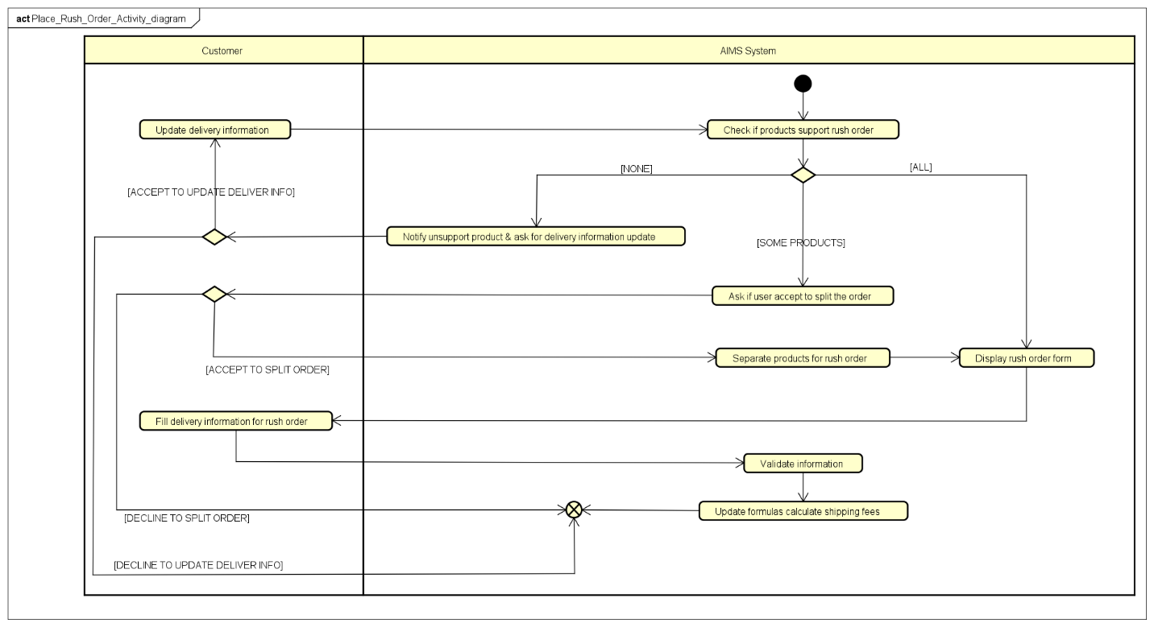

### ***Input data***

**Input data for rush delivery information**

|  |  |  |  |  |  |
| --- | --- | --- | --- | --- | --- |
| **No.** | **Data field** | **Description** | **Mandatory** | **Valid conditions** | **Example** |
| 1 | Receiver name |  | Yes |  | Nguyen Thi Thu Trang |
| 2 | Phone number |  | Yes | - All numbers  - At least 10 digits | 0123456789 |
| 3 | District | Select from list | Yes |  | Dong Da |
| 4 | Ward | Select from list | Yes |  | Trung Phung |
| 5 | Address |  | Yes |  | 123 X Street |
| 6 | Shipping notes/instruction |  | No |  | Turn left on the last crossroad. Please ship in work time |

### ***Output data***

None

## **USECASE “PAY ORDER”**

### ***Descriptions and flows***

|  |  |  |  |  |  |  |
| --- | --- | --- | --- | --- | --- | --- |
| **Usecase** | **PAY ORDER** | | | | | |
| **Usecase code** | **UC-260** | | | | | |
| **Actors** | 1. Customer  2. Interbank | | | | | |
| **Brief description** | The customer enters transaction information. AIMS collects these information and contacts the interbank for performing payment. | | | | | |
| **Preconditions** | Customer has confirmed the invoice | | | | | |
| **Main flow of event** | **Step** | **Actor** | **Action** | | | |
| 1 | System | AIMS displays form for entering transaction information | | | |
| 2 | Customer | Customers fills in transaction information | | | |
| 3 | System | AIMS validates information | | | |
| 4 | System | AIMS send request to interbank for performing transaction | | | |
| 5 | Interbank | Interbank checks for transaction validity | | | |
| 6 | Interbank | Interbank performs transaction | | | |
| 7 | Interbank | Interbank notifies AIMS about transaction success | | | |
| 8 | System | AIMS records payment details and set the order to pending state | | | |
| 9 | System | AIMS display payment details to customer | | | |
| 10 | System | AIMS sends and email of invoice transaction information to customer | | | |
| **Alternative flow of event** | **No.** | **At step** | **Conditions** | **Actor** | **Action** | **Cont. at step** |
| 1 | 3 | Customer enters invalid credit card number | System | AIMS asks the customer to input the credit card number again | 1 |
| 2 | 5 | Customer’s account does not have enough amount for transaction | Interbank | Interbank sends AIMS notifications about transaction failure |  |
| System | AIMS goes back to alternative flow 8 of “PLACE ORDER” usecase |  |
| 3 | 5 | Transaction failed due to errors of interbank | Interbank | Interbank sends AIMS notifications about transaction failure |  |
| System | AIMS goes back to alternative flow 8 of “PLACE ORDER” usecase |  |
| **Postconditions** | None | | | | | |

**Activity diagram**

### ***Input data***

**Input data for transaction information**

|  |  |  |  |  |  |
| --- | --- | --- | --- | --- | --- |
| **No.** | **Data field** | **Description** | **Mandatory** | **Valid conditions** | **Example** |
| 1 | Card holder name |  | Yes |  | NGUYEN THI THU TRANG |
| 2 | Card number |  | Yes | - 16 digits  - Match interbank | 6234 5678 9012 3456 |
| 3 | Secure digits | On the back of the credit card | Yes | - 3 digits | 505 |
| 4 | Interbank | Select from list | Yes |  | Vietcombank |

### ***Output data***

**Output specs for transaction record**

|  |  |  |  |  |
| --- | --- | --- | --- | --- |
| **No.** | **Data field** | **Description** | **Format** | **Example** |
| 1 | Cardholder name | Name of the cardholder | String, all caps | NGUYEN THI THU TRANG |
| 2 | Transaction ID | ID of the transaction | - 24 characters, separated by dash every tuple of 4  - The 3rd and 5th tuples are all digits, the remaining tuples are all letters  - String, all caps | QKSV-KJAR-1324-SAFB-3218-DSFB |
| 3 | Date issued | The date when the transaction is performed | DD Mon, YYYY | 23 Apr, 2021 |
| 4 | Payment method | Method for paying for the order | Type of credit card (identified by the first digit of card number), Name of interbank | Visa, Vietcombank |
| 5 | Total | Amount to be paid | - Space separating thousands  - Positive integer | 636 000 |

## **USECASE “REFUND ORDER”**

### ***Descriptions and flows***

|  |  |  |  |
| --- | --- | --- | --- |
| **Usecase** | **REFUND ORDER** | | |
| **Usecase code** | **UC-270** | | |
| **Actors** | Interbank | | |
| **Brief description** | The customer decides to cancel the order. AIMS requests the bank to return payment for customer and remove the order from pending state | | |
| **Preconditions** | Customer has confirmed the invoice and perform transaction successfully | | |
| **Main flow of event** | **Step** | **Actor** | **Action** |
| 1 | System | AIMS sends notifications to interbank about refund |
| 2 | Interbank | Interbank validates refund requests |
| 3 | Interbank | Interbank returns money to customer and notify AIMS |
| 4 | System | AIMS changes the state of order to “Discarded by customer” |
| 5 | System | AIMS notifies customer about refund successfully |
| **Alternative flow of event** | None | | |
| **Postconditions** | None | | |

### ***Input data***

None

### ***Output data***

None